如何更新KA17的固件
How to update the firmware for the KA17

在更新固件之前，建议先阅读以下注意事项：
1、在为KA17更新固件之前，建议拔掉电脑上USB接口的其他解码器，以免固件升级失败！
2、KA17固件更新支持使用Windows电脑和MAC电脑。本固件更新文档以Windows电脑为例，MAC电脑更新固件也可以参考本文档。
特别说明，如果你使用的是MAC电脑，请根据电脑所使用的芯片和KA17现有固件版本选择不同的固件更新工具：
1）Intel芯片，并且KA17固件版本为V0.84：请选择KA17 V2.00 For MAC Computer\For Intel Chip MAC\KA17 V0.84 firmware upgrade V2.00文件夹下的固件更新工具。
2）Intel芯片，并且KA17固件版本为V0.99：请选择KA17 V2.00 For MAC Computer\For Intel Chip MAC\KA17 V0.99 firmware upgrade V2.00文件夹下的固件更新工具。
3）M芯片，并且KA17固件版本为V0.84：请选择KA17 V2.00 For MAC Computer\For M Chip MAC\KA17 V0.84 firmware upgrade V2.00文件夹下的固件更新工具。
4）M芯片，并且KA17固件版本为V0.99：请选择KA17 V2.00 For MAC Computer\For M Chip MAC\KA17 V0.99 firmware upgrade V2.00文件夹下的固件更新工具。
3、KA17固件更新完成后，请搭配使用V3.22版本的FiiO Control App。如果App没有更新，可以将文件夹中的“FiiOControl-FiiORelease-v3.22-2404261610.apk”导入到设备中安装使用。
4、如遇到KA17插入USB升级时弹出“升级失败”弹窗时，可以按一下KA17的关闭/点亮屏幕的按键，KA17会正常进入主界面，这时不要拔掉USB数据线，把升级工具重新打开升级一遍，升级完再拔插一下USB等待KA17升级完成。
Before updating the firmware, it is recommended to read the following precautions:
1. Before updating the firmware for KA17, it is recommended to unplug other decoders from the USB interface on the computer to avoid firmware upgrade failure!
2. KA17 firmware update supports Windows computers and MAC computers. This firmware update document takes a Windows computer as an example. You can also refer to this document to update firmware on MAC computers.
Special note, if you are using a MAC computer, please choose different firmware update tools according to the chip used by the computer and the existing firmware version of KA17:
1) Intel chip, and the KA17 firmware version is V0.84: Please select the firmware update tool under the KA17 V2.00 For MAC Computer\For Intel Chip MAC\KA17 V0.84 firmware upgrade V2.00 folder.
2) Intel chip, and the KA17 firmware version is V0.99: Please select the firmware update tool under the KA17 V2.00 For MAC Computer\For Intel Chip MAC\KA17 V0.99 firmware upgrade V2.00 folder.
3) M chip, and the KA17 firmware version is V0.84: Please select the firmware update tool under the KA17 V2.00 For MAC Computer\For M Chip MAC\KA17 V0.84 firmware upgrade V2.00 folder.
4) M chip, and the KA17 firmware version is V0.99: Please select the firmware update tool under the KA17 V2.00 For MAC Computer\For M Chip MAC\KA17 V0.99 firmware upgrade V2.00 folder.
3. After the KA17 firmware update is completed, please use the V3.22 version of the FiiO Control App. If the App is not updated, you can import "FiiOControl-FiiORelease-v3.22-2404261610.apk" in the folder to the device for installation and use.
4. If the "Upgrade failed" pop-up window pops up when KA17 is plugged into USB for upgrade, you can press the button of KA17 to close/light up the screen. KA17 will enter the main interface normally. At this time, do not unplug the USB data cable and put the upgrade in. Re-open the tool and upgrade again. After the upgrade, unplug and plug in the USB and wait for the KA17 upgrade to complete.

KA17 V2.00固件更新内容：
1、新增电脑端网页版对PEQ的控制（https://fiiocontrol.fiio.com/）；
2、新增PEQ的高通、低通滤波器类型选择；
3、新增多个FiiO Control App控制内容，包括滤波器、增益、音量等；
4、新增三种按键模式选择(A/B/C)，支持播放/暂停，上一曲/下一曲（独占模式不支持）；
5、优化打开EQ音量会变小问题；
6、优化不打开EQ不能进入FiiO Control App设置问题；
7、优化打开EQ后在独占模式选择32位深播放无输出问题。
KA17 V2.00 firmware update content:
1. Added control of PEQ on the website of PC (https://fiiocontrol.fiio.com/).
2. Added high-pass and low-pass filter options for PEQ.
3. Added multiple control options for FiiO Control App, including filters, gain, and volume.
4. Added three modes (A/B/C) for the button control, supporting play/pause, previous track/next track (not supported Exclusive USB Audio Excess Mode).
5. Fixed the issue where volume would decrease when enabling EQ.
6. Fixed the issue where settings on FiiO Control App cannot be accessed without enabling EQ.
7. Fixed the issue where there was no output when playing 32-bit audio in the Exclusive USB Audio Excess Mode after enabling EQ.

KA17 V2.00固件更新教程：
KA17 V2.00 firmware update tutorial:
1、在Windows电脑中安装FiiO USB DAC驱动V5.62。如果您的Windows电脑中已经安装了其他版本的FiiO USB DAC驱动，请卸载掉，之后再安装V5.62版本的驱动。安装完成V5.62驱动后，建议重启电脑。如果您已经安装了FiiO USB DAC驱动V5.62，请忽略此步骤。
如果你使用的是MAC电脑，则不需要安装驱动。
https://bbs.fiio.com/note/showNoteContent.do?id=201911191752415983705&tid=16
1. Install FiiO USB DAC driver V5.62 on your Windows computer. If other versions of the FiiO USB DAC driver are already installed on your Windows computer, please uninstall it and then install the V5.62 driver version. After installing the V5.62 driver, it is recommended to restart the computer. If you have already installed FiiO USB DAC driver V5.62, please ignore this step.
If you are using a MAC computer, you do not need to install the driver.
https://forum.fiio.com/note/showNoteContent.do?id=202105191527366657910&tid=17

2、将KA17与Windows电脑连接。为了避免因电脑USB接口供电不足导致升级失败，尽量选择电脑后面板的USB接口进行升级。
2. Connect KA17 to the Windows computer. In order to avoid upgrade failure due to insufficient power supply of the computer USB interface, try to choose the USB interface on the back panel of the computer for upgrade.

3、升级固件前请把KA17的D.MODE开关切换为OFF状态，USB模式切换为U2.0，不要播放音乐。在升级固件的时候，不要晃动USB数据线，以免升级失败。
3. Before upgrading the firmware, please switch the D.MODE switch of KA17 to OFF state, switch the USB mode to U2.0, and do not play music. When upgrading firmware, do not shake the USB data cable to avoid upgrade failure.

4、升级固件前，请将KA17菜单设置中的“MQA”选项选择为“打开”状态；如果该固件没有“MQA”选项，请将菜单设置中的“EQ”选项选择为“关闭”状态。
4. Before upgrading the firmware, please select the "MQA" option in the KA17 menu settings to "ON"; if the firmware does not have an "MQA" option, please select the "EQ" option in the menu settings to "OFF".

5、双击“FiiO_Dfu_KA17”打开烧录工具，选择“Fiio_KA17_xmos_dfu_V200.bin”，之后点击Start进行升级。
5. Double-click "FiiO_Dfu_KA17" to open the burning tool, select "Fiio_KA17_xmos_dfu_V200.bin", and then click Start to upgrade.
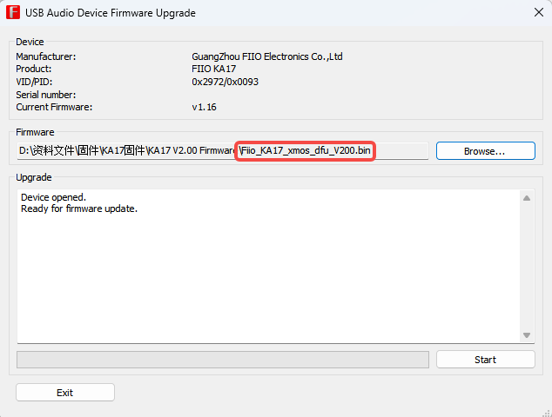

6、当出现“Firmware upgrade finished successfully”时，可以将KA17拔下（此时请勿将USB线从Windows电脑拔下），之后KA17再连接USB线，此时KA17的屏幕会出现“升级中，预计需三分钟，请勿拔USB”的升级弹窗，请耐心等待升级完成。当升级完成后，屏幕会出现“升级完成”的字样，即表示KA17固件升级成功。
6. When "Firmware upgrade finished successfully" appears, you can unplug KA17 (do not unplug the USB cable from the Windows computer at this time), and then connect the KA17 to the USB cable. At this time, the screen of KA17 will display "Updating, about 3 mins, PLS don’t unplug USB", please wait patiently for the upgrade to complete. When the upgrade is completed, the words "UPDATE OK" will appear on the screen, indicating that the KA17 firmware upgrade is successful.

7、固件升级成功后，可以重新拔插KA17，之后就可以在KA17的菜单中看到版本号已显示为2.00，并且FiiO控制面板上也版本号显示为v2.00。
7. After the firmware upgrade is successful, you can re-plug KA17. Then you can see that the version number is displayed as 2.00 in the KA17 menu, and the version number is also displayed as v2.00 on the FiiO control panel.
